CHAPETER FOUR
STEADY STATE SINGLE PHASE AC CIRCUIT ANALYIS
……………………………………………………………………………………….
Introduction to Ac generator
Electricity is produced by generators at power stations and then distributed by a vast network of transmission lines (called the National grid system) to industry and for domestic use. It is easier and cheaper to generate alternating current (AC) than direct current (DC) and ac is more conveniently distributed than dc. Since its voltage can be readily altered using transformers.
One way to generate an ac voltage is to rotate a coil of wire at constant angular velocity in a fixed magnetic field. The magnitude of the resulting voltage is proportional to the rate at which flux lines are cut (Faraday’s law), and its polarity is dependent on the direction the coil sides move through the field. Since the rate of cutting flux varies with time, the resulting voltage will also vary with time.
For example in fig 4.1 in (a), since the coil sides are moving parallel to the field, no flux lines are being cut and the induced volt- age at this instant (and hence the current) is zero. (This is defined as the 0⁰ position of the coil.) As the coil rotates from the 0⁰ position, coil sides AA’ and BB’ cut across flux lines; hence, voltage builds, reaching a peak when flux is cut at the maximum rate in the 90⁰position as in (b). Note the polarity of the voltage and the direction of current. As the coil rotates further, voltage decreases, reaching zero at the 180⁰ position when the coil sides again move parallel to the field as in (c). At this point, the coil has gone through a half-revolution.
During the second half-revolution, coil sides cut flux in directions opposite to that which they did in the first half revolution; hence, the polarity of the induced voltage reverses. As indicated in (d), voltage reaches a peak at the270⁰ point, and, since the polarity of the voltage has changed, so has the direction of current. When the coil reaches the 360⁰ position, voltage is again zero and the cycle starts over.Figure4.2 shows one cycle of the resulting wave form. Since the coil rotates continuously, the voltage produced will be a repetitive, periodic wave form (a waveform that continually repeats itself after the same time interval).

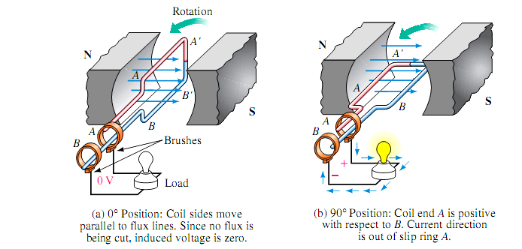

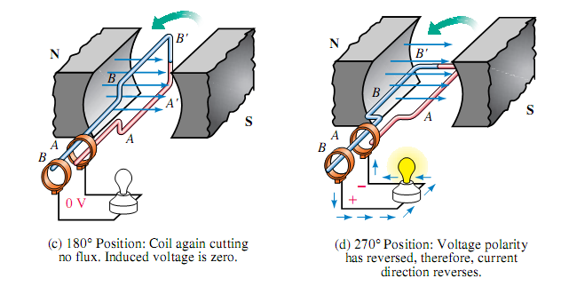

Fig 4.1 Generating an AC voltage.
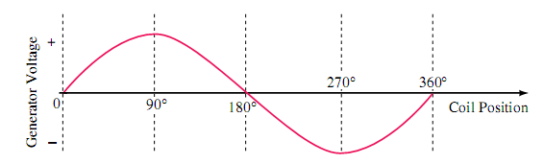

Fig 4.2 Coil voltage versus angular position

Sinusoidal terminologies
period (T): the time taken for an alternating quantity to complete one cycle is called the period of the waveform.
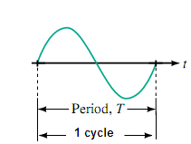

Frequency: the number of cycles completed in one second is called the frequency of the waveform and measured n hertz, Hz.
$$1hertz\left(Hz\right)=1cyclepersecond$$
The Period and frequency of a sin wave can be related by the following equation:
$$T=\frac{1}{f}∨f=\frac{1}{T}$$
Example1. Two sources have frequencies f₁ and f₂ respectively. If f₂=2f₁ and T₂ is 20ms, determine f1, f_{2,} and T₁?
$$f_{2}=\frac{1}{T_{2}}=\frac{1}{20ms}=50Hz$$
$$f_{1}=\frac{f_{2}}{2}=\frac{50Hz}{2}=25Hz$$
$$T_{1}=\frac{1}{f_{1}}=\frac{1}{25Hz}=40ms$$
Example 2. An alternating current completes 5 cycles in 8ms. What is its frequency?
Instantaneous value: the magnitude of a waveform at any instant of time; denoted by lower case letters (e₁,e₂,i₁,i₂…)
Peak value: the maximum instantaneous value of a waveform as measured from the zero-volt level.
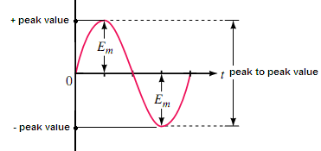

Peak-to-peak value: the full voltage between positive and negative peaks of the waveform, that is, the sum of the magnitude of the positive and negative peaks.
Average (mean) value:
Because a sine wave is symmetrical, its area below the horizontal axis is the same as its area above the axis; thus over a complete cycle the average value is zero. The average of half a sine wave, however, is not zero.
Therefore the average value of sin wave is the average value measured over a half cycle.
$$Average\left(mean\right)value=\frac{areaunderthecurve}{lengthofbase}$$
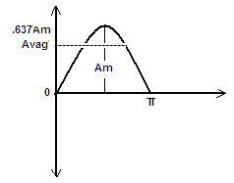

$$Area=\int_{0}^{π}{A}msinαdα$$
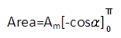

=-A_{m}(cosπ-cos0⁰)
=-A_{m}[-1-(+1)]=-A_{m}(-2)
Area=2A_{m}
Since we know the area under the positive pulse, we can easily determine the average value the positive region of a sine wave:
$$Average\left(mean\right)value=\frac{Areaunderthecurve}{baselength}$$
$$\frac{2A_{m}}{π}$$
Average value=0.637A_{m}
Equation of sinusoidal waveform
The basic mathematical formula for the sinusoidal waveform is:
$$e=E_{m}sinα$$
Where e is instantaneous voltage, E_{m} is the maximum coil voltage and α is the instantaneous angular position of the coil.
Angular Velocity (ω) the rate at which the generator coil rotates is called its angular velocity.
$ω=\frac{α}{t}$ Where, α is angular distance and t is time
$$α=ωt$$
In practice, ω is usually expressed in radians per second, where radians and degrees are related by the identity. $2πradians={360}^{0}$

Relationship between ω,T and f
One cycle of sine wave may be represented as either $α=2πrads$ or t=Ts. Substituting these in to $α=ωt$ you get 2π=ωt transposing yields
$$ωT=2π\left(rad\right)$$
Thus,
$ω=\frac{2π}{T}$
Recall f=1/T Hz. Substituting this it to in the above equation you get
$$ω=2πf\left({rad}/{sec}\right)$$
$e=E_{m}sinα$ but $α=ωt$
Combining these equations yields
$$e=E_{m}sinωt$$
Similarly
$i=I_{m}sinωt$
Substitute $ω=2πf$ to the above equation yields
$e=E_{m}sin2πft$
The general expression for an alternating voltage is
$v=V_{m}sin\left(ωt±θ\right)$
Phasor
The instantaneous levels of alternating current and voltage are vector quantities, since these levels are continuously changing, an ac waveform must be represented by rotating vector or phasor.
A phasor is a rotating line whose projection on a vertical axis can be used to represent sinusoidally varying quantities.
The sinusoidal output voltage from the simple generator can be represented by the phasor diagram.
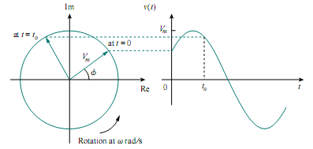
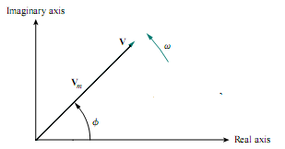
Fig 4.3 (a) phasor reperesentation of AC waveform (b) phasor diagrma
$v=V_{m}<θ$
Voltages and currents with phase shifts
If a sine wave does not pass through zero at t=0 it has a phase shift. Waveforms may be shifted to the left or to the right.
Mathematical equation for a waveform shifted to left
$$v=v_{m}sin⁡\left(ωt+θ\right)$$
Mathematical equation for waveform shifted to right
$$v=v_{m}sin⁡\left(ωt−θ\right)$$
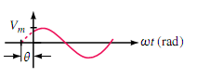
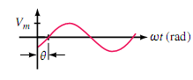

(a) $v=v_{m}sin\left(ωt−θ\right)$ $\left(b\right)v=v_{m}sin⁡\left(ωt+θ\right)$
Fig 4.4 Phase shifted sine waves
Sometimes voltages and currents are expressed in terms of $cosωt$ rather than $sinωt$.a cosine wave is a sine wave shifted by$+{90}^{0}$, or alternatively, a sine wave I a cosine wave shifted by$−{90}^{0}$.
$$cos\left(ωt+θ\right)=sin⁡\left(ωt+θ+{90}^{0}\right)$$
$$sin\left(ωt+θ\right)=cos⁡\left(ωt+θ−{90}^{0}\right)$$
Phase difference
Phase difference refers to the angular displacement between different waveforms of the same frequency. If the angular displacement between two wave forms is 0⁰ the waveforms are said to be in phase; otherwise, they are out of phase.
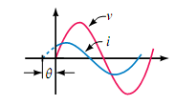
When describing a phase difference, select one waveform as reference. Other waveforms then lead, lag, or are in phase with this reference.
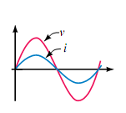
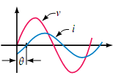

a) In phase (b) out of phase(current leads) (c) out of phase(current lags)
Fig 4.4 illustrating phase difference

Effective value (rms)
An effective value is an equivalent dc value: it tells us how many volts or Amps of dc that a time-varying waveform is equal to in terms of its ability to produce average power. A familiar example of such a value is the value of the voltage at the wall outlet in your home.
The effective value of a sine wave can be determined using the circuits of fig 4.
- Consider a sinusoidal varying current i(t). By definition, the effective value of i is that value of dc current that produces the same average power.
- Consider (b). Let the dc source be adjusted until its average power is the same as the average power in (a). the resulting dc current is then the effective value of the current of(a).to determine this value, determine the average power for both cases, then equate them.
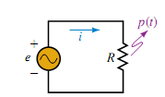
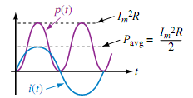

(a) AC circuit

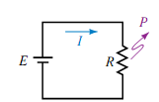
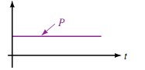

(b) DC circuit
Fig 4.5 Determining the effective value of a sinusoidal ac.
First, consider the dc case. Since current is constant, power is constant and average power is
$$P_{avg}=P=I^{2}R$$
Now consider the ac case. Power to the resistor at any value of time is P(t) i²R, where i is the instantaneous value of current.
$$P_{ac=}$$
But
$\sin^{2}ωt=\frac{1}{2}\left(1−cos2ωt\right)$ (trigonomeric identity)

Therefore
$P_{ac}=ℑ^{2}\left[\frac{1}{2}\left(1−cos2ωt\right)\right]R$
And $P_{ac}=\frac{ℑ^{2}}{2}R−\frac{ℑ^{2}}{2}Rcos2ωt$
To get the average of P(t), note that the average of cos2ωt is zero and thus the last term of the above equation drops off leaving
$$P_{avg}=\frac{ℑ^{2}}{2}R$$
Equating the average power delivered by the ac generator to that delivered by the dc source,
$$P_{avg}=P_{dc}$$
$$\frac{ℑ^{2}}{2}R={Idc}^{2}R∧I_{m}=\sqrt{2}I_{dc}$$
or
$I_{dc}=\frac{I_{m}}{\sqrt{2}}=0.0707I_{m}$
which,in words, states that the equivalent dc value of a sinusoidal current or voltage is 1/$\sqrt{2}$ or 0.707 of its maximum value.
In summery,
$I_{dc}=I_{rms}\left(effectivevalue\right)=0.707I_{m}$ and
$$V_{rms}=0.707V_{m}$$
Example 2.An alternating voltage is given by $v=282.8sin314tV.$find (a) the rms voltage (b) average voltage(c) the frequency and (d) the instantaneous value of voltage at t=4ms.

The general expression for an alternating voltage is:
$$v=V_{m}sin\left(ωt±θ\right)$$
a.$v_{rms}=0.707∗V_{m}=0.707∗282.8V=200V$
b. $averagevoltage=0.637∗V_{m}=0.637∗282.8=180.14V$
c. $angularvelocity,ω=314{rad}/{sec},i.e2πf=314$
$$f=\frac{314}{2π}=50Hz$$
d. $att=4ms,v=282.8sin\left(314∗4∗{10}^{−3}\right)=268.9V$
Example 3. An alternating voltage is given by $v=75sin\left(200πt−{30}^{0}\right)V$
Find (a) the amplitude,(b)the peak-to-peak value, (c) the rms value, (d) the periodic time, (e)the frequency,(f) the phase angle relative to $75sin200πt$
Comparing $v=75sin\left(200πt−{30}^{0}\right)V$ with the general expression $v=V_{m}sin\left(ωt±θ\right)$ gives:
- $$amplitude,∨peakvalue=75V$$
- $$peak−−peakvalue=2∗75=150V$$
- $$thermsvalue=0.707∗maximumvalue=0.707∗75=150V$$
- $$angularvelocity,ω=200π{rad}/s$$
$$henceperiodictime,T=\frac{2π}{ω}=\frac{2π}{200π}=10ms$$
- $$frequency,f=\frac{1}{T}=\frac{1}{0.01}=100Hz$$
- $$phaseangleθ={30}^{0}lagging75sin200πt$$

Exercise 1
1. If you double the rotational speed of an ac generator, what happens to the frequency and period of the waveform?
2. A 10Hz sinusoidal current has a value of 5A at t=25ms. What is its value at t=75ms?
3. Determine the phase relationship between voltage and current given by the following equations:
$v=50sin\left(ωt+{20}^{0}\right)∧V$ $i=10cos⁡\left(ωt−{45}^{0}\right)A$
4. A sinusoidal current has a peak value of 30A and a frequency of 60Hz. At time t=0, the current is zero. Express the instantaneous current in the form$i=I_{m}sinωt$.
5. An alternating voltage v has a periodic time of 20ms and a maximum value of 200V. when time t=0, v=-75V. Deduce a sinusoidal expression for v and sketch one cycle of the voltage showing impotent points.
6.An alternating voltage is represented by $v=20sin$ find(a) the maximum value (b) the frequency (c) the periodic time (d) rms value (e) average value

Complex number review
A complex number is a number of the form $C=a+jb,$
where a and b are real numbers and $j=\sqrt{−1}$. The number a is called the real part of C and b is called its imaginary part.
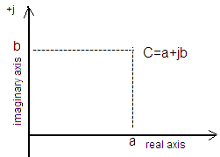
complex numbers may be represented geometrically, either in rectangular form or in polar form as points on a two-dimensional plane called the complex plane.
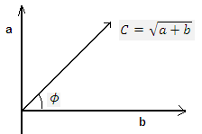

Rectangular form polar form
$$C=a+jb\left(rectangularform\right)$$
$$C=C<ϕ\left(polarform\right)$$

Converstion between two forms
The two forms are related by the following equation,
Rectangular to polar
$C=\sqrt{a^{2}+b^{2}}$
$$θ=\tan^{−1}\frac{b}{a}$$
Polar to rectangular
$a=Ccosθ$
$$b=Csinθ$$
Mathematical operations with complex number
Let us first examine the symbol j associated with imaginary numbers by definition,
$j=\sqrt{−1}$, $j^{2}=−1$ , $\frac{1}{j}=−j$
Complex conjugect
The conjugate or complex conjugat of a complex number can be found by simply changing the sign of the imaginary part in the rectanguar form or by using the negative of the angle ot the polar form.
The conjugate of $C=a+jb$ is $C=a−jb$
The conjugate of C$C<θ$ is C$C<−θ$
Addition
To add two or more complex numbers, simply add the real and imaginary parts separately.
${ifC}_{1}=a_{1}+{jb}_{1}$ and $C_{2}=a_{2}+{jb}_{2}$
then
$C_{1}+C_{2}=\left(a | | 1+a_{2}\right)+j\left(b_{1}+b_{2}\right)$
Subtaction
${ifC}_{1}=a_{1}+{jb}_{1}$ and $C_{2}=a_{2}+{jb}_{2}$
Then $C_{1}−C_{2}=\left(a_{1}−a_{2}\right)+j\left(b_{1}−b_{2}\right)$
Addition or subtraction can not be performed in polar form unless the complex numbers have the same angle$θ$ .
Multiplication
To multiply two complex numbers in rectanguar form, mulitiply the real and imaginary parts of one in turn by the imaginary parts of the other.
${ifC}_{1}=a_{1}+{jb}_{1}$ and $C_{2}=a_{2}+{jb}_{2}$
Then $C_{1}∗C_{2}=\left(a_{1}+jb_{1}\right)∗j\left(a_{2}+{jb}_{2}\right)$
$$C_{1}∗C_{2}=\left(a_{1}a_{2}−b_{1}b_{2}\right)+j\left(b_{1}a_{2}+a_{1}b_{2}\right)$$
To mulitiply two complex numbers in polar form,mulitiply magnitudes and add angles algebraically.
$ifC_{1}=θ_{1}$ and $C_{2}=θ_{2}$
Then $C_{1}∗C_{2}=C_{1}∗C_{2}<θ_{1}+θ_{2}$
Division
To divide two complex numbers in rectangular form, multiply the numerator and denominatior by the conjugate of the denomnator and resulting real and imaginary parts collected. That is, if
${ifC}_{1}=a_{1}+{jb}_{1}$ and $C_{2}=a_{2}+{jb}_{2}$
$$\frac{C_{1}}{C_{2}}=\frac{\left(a_{1}+jb_{1}\right)∗j\left(a_{2}−{jb}_{2}\right)}{\left(a_{2}+jb_{2}\right)∗j\left(a_{2}−{jb}_{2}\right)}$$
$\frac{\left(a_{1}a_{2}+b_{2}\right)+j\left(b_{1}a_{2}−a_{1}b_{2}\right)}{{a_{2}}^{2}+{b_{2}}^{2}}$
In polar form, division is accomplished by simply dividing the magnitde of the numerator by the magnitude of the denominator and subtracting the ange of the denominator from the numerator.
$ifC_{1}=θ_{1}$ and $C_{2}=θ_{2}$
$$\frac{C_{1}}{C_{2}}=\frac{C_{1}}{C_{2}}<θ_{1}−θ_{2}$$

AC circuits
R,L and c circuit elements each have quite different electrical poroperties. Resistance, for example, opposes current, while inductance opposes changes in current and capacitance opposes change in voltage. These differences result in quite different voltage-current relationships.
Resistance in AC circuit(pure resistive circuit)
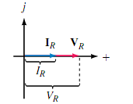
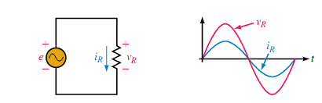

(a) Circuit diagram (b) waveform (c) phasor diagram
Fig 4.6 Pure resistive circuit
In a pure resistive circuit current is in phase with voltage.
The relation illustrated in fig4.6 May be stated mathematical as:
$i_{R}=\frac{V_{R}}{R}=\frac{Vmsinωt}{R}=I_{m}sinωt$ where, $I_{m}=\frac{V_{m}}{R}$
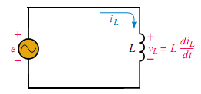
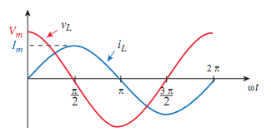
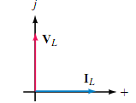
Inductance in AC circuit

- Circuit diagram (a) voltage and current wavforms (c) phasor diagram
Fig 4.7 pure inductive circuit
For an ideal inductor, volage V_{L} is prortional to the rate of chage of current. Because of this, voltgae and current are not in phase as they are for a resistive circuit.
$$V_{L}=\frac{Ldi_{L}}{dt}=L\frac{d}{dt}\left(I_{m}sinωt\right)=ωLI_{m}cosωt=V_{m}cosωt$$
Where $V_{m}=ωLI_{m}$
Utilizing the trigonometric idntity $cosωt=sin⁡\left(ωt+{90}^{0}\right)$, you can write this as:
$$V_{L}=V_{m}sin⁡\left(ωt+{90}^{0}\right)$$
For a pure inductive circuit current lage volage by 90^{0.}

Inductive reactance(X_{L})
From the above equation $V_{m}=ωLI_{m}$
thus $\frac{V_{m}}{I_{m}}=ωL$
This ratio is defined as inductive reactance and is give the symbol X_{L.} since the ratio of volts to amps is ohms, reactance has units of ohms.
Thus $X_{L}=\frac{V_{m}}{I_{m}}=ωL$
$$XL=ωL$$
But, $ω=2πf$
$X_{L}\left(inductivereactance\right)=2πfL$ (Ω)
Reactane X_{L} represents the opposition that inductance presents to current for the sunusoidal as case.
We now have everything that we need to solve simple inductive circuits with sinusoidal excitation, that is ,we know that current lags voltage by 90⁰ and that their amplitudes are related by
$$I_{m}=\frac{V_{m}}{X_{L}}$$
$$V_{m=I_{m}X_{L}}$$
Example 4.A 0.5H inductor is conneceted across AC source. If the voltage across the inductor is $v=100sin20t$ determine the inductive reactance and write the expression for the current.
$$X_{L}=ωL=2πfL$$
$$X_{L}=\left(20{rad}/s\right)\left(0.5H\right)=10Ω$$
$I_{m}=\frac{V_{m}}{X_{L}}=\frac{100V}{10Ω}=10A$ we know that i lags v by 90⁰. Therefore,
$i=10sin⁡\left(20t−{90}^{0}\right)$ A

Capacitance in Ac circuit(pure capacitve circuit)
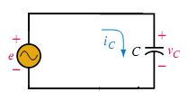
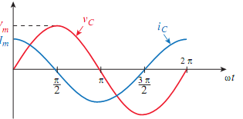
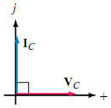
(a)circuit diagram (b) Weave form (c) phase diagram
Fig 4.8 pure capacitve circuit
For capacitance, current is proportional to the rate for change of voltage, i.e.
$$i_{c}=c\frac{dV_{C}}{dt}=c\frac{d}{dt}\left(V_{m}sinωt\right)=ωcV_{m}cosωt$$
$i_{c}=I_{m}cosωt$ where $I_{m}=ωcV_{m}$
Using the appropriate trigomometric identity($cos\left(ωt\right)=sin⁡\left(ωt+{90}^{0}\right)$), the above equation can be written as
$$i_{c}=I_{m}sin⁡\left(ωt+{90}^{0}\right)$$
For a purely capacitive circuit, current leads voltage by 90⁰.

Capactive ractance(X_{C})
Now consider the relationship between maximum capacitor voltage and current magnitudes.
$$I_{m}=ωCV_{m}$$
Rearranging, we get
$\frac{V_{m}}{I_{m}}=\frac{1}{ωC}$
The ratio of V_{m} to I_{m} is defined as capacitive reactance and is given the symbol X_{c}. that is,
$$X_{c}=\frac{V_{m}}{I_{m}}=\frac{1}{ωC}\left(Ω\right)$$
$X_{c}=\frac{1}{ωC}$ but, ω=2πf
Thus,
$X_{C}\left(capactivereactance\right)=\frac{1}{2Πfc}$ (Ω)
Reactance X_{C} represents the opposition that capacitance presents to current for the sinusoidal ac case.
We now have everything that we need to solve simple capacitive circuits with sinusoidal excitation. i.e., we know that current leads voltage by 90⁰ and that
$$I_{m}=\frac{V_{m}}{X_{C}}$$
And $V_{m}=I_{m}X_{C}$
Example 4.A 1µFcapacitor is conneceted across AC source. If the voltage across the capacitor is $v=30sin400t$ determine the capacitive reactance and write the expression for the current.
$$X_{C}=\frac{1}{ωC}=\frac{{10}^{6}}{400}Ω=2500Ω$$
$$I_{m}=\frac{V_{m}}{X_{C}}=\frac{30V}{2500Ω}=12mA$$
and we know that for acapcitor i leads v by 90⁰. Therefore,
$i=12sin\left(400t+{90}^{0}\right)mA$
AC series circuit
When we examined dc circuits we saw that the current everywhere in series circuit is a always constant. This same applies when we have series elements with ac sources.
Further, we had seen that the total resistance of a dc series circuit consisting of n resistors was determined as:
$R_{T}=R_{1}+R_{2}……..R_{n}$
When working with ac circuits we no longer work with only resistance but also with capacitive and inductive reactance.
Impedance
Impedance is a term used to collectively determine how the resistance, capacitance, and inductance “impede” the current in ac circuit. The symbol for impedance is the letter Z and the unit is the ohm (Ω).
Because impedance may be made up of any combination of resistance and reactance, it is written as a vector quantity Z,
The polar form impedance is written as:
$Z=Z<ϕ$ (Ω)
The value Z is the magnitude(in ohms) of the impedance vector Z and is deteremined as:
$$Z=\sqrt{R^{2}+X^{2}}\left(Ω\right)$$
The corresponding angle of the impedance vector is determined as:
$$ϕ=±\tan^{−1}\left(\frac{X}{R}\right)$$
The rectangular form of impedance is written as
$Z=R±jX$ , Where R is resistance and X is reactance (XL or XC)
If we are given the polar form of the impedance, then we may determine the equivalent rectangular expression from.
$R=Zcosϕ$ and $X=Zsinϕ$
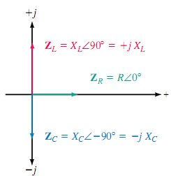
Fig 4.9 Impedance diagram
Resistive impedance Z_{R} is a vector having a magnitude of R along the positive real axis, Inductive impedance Z_{L} is a vector having a magnitude of X_{L} along the positive imaginary axis, while the capacitive impedance Z_{c} is a vector having a magnitude of X_{c} along the negative imaginary axis. Mathematically, each of the vector impedance is written as follows
$$Z_{R}=R<0^{0}=R+j0=R$$
$Z_{L}=X_{L}<{90}^{0}=0+jX_{L}={jX}_{L}$
$Z_{C}=X_{C}<{−90}^{0}=0−jX_{C}=−jX_{L}$
R-L circuit
RL circuit is the combination of resistive and inductive load.
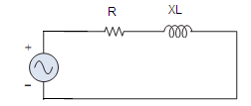

Fig 4.10 RL circuit
In RL circuit the total impedance Z is
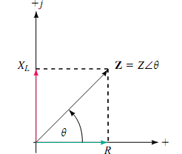
$$Z=R+jX_{L}∨Z=Z<\tan^{−1}\left(\frac{X_{L}}{R}\right)$$
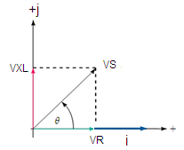
Fig4.11 (a) impedance diagram (b) phasor diagram
Voltage across resistor(R) and inductor(L) can be determined as
$$V_{R}=i∗Z_{R}$$
$V_{L}=i∗Z_{L}=i∗X_{L}$
Thus the total voltage (supply voltage, V_{s})
$$V_{s}=V_{R}+jV_{L}$$
The total circuit current (i):
$$i=\frac{V_{s}}{Z}=\frac{V_{R}+jV_{L}}{R+jX_{L}}∨$$
$i=\frac{V_{s}<ϕ_{1}}{Z<ϕ_{2}}=\frac{V_{s}}{Z}<ϕ_{1}−ϕ_{2}$
Example 5. A 4Ω resistor and a 9.55mH inductor are connected in series with 240 V, 50 Hz AC source. Calculate (a) inductive reactance (b) the impedance, (c) the total current, and (d) draw impedance and phasor diagram.
- $$inductivereactance,X_{L}=2πfL=2π\left(50\right)\left(9.55∗{10}^{−3}\right)=3Ω$$
- $$impedance,Z=\sqrt{R^{2}+{X_{L}}^{2}}=\sqrt{4^{2}+3^{2}}=5Ω$$
- $$current,i=\frac{v}{z}=\frac{240V}{5Ω}=48A$$
d. $ϕ=\tan^{−1}\frac{X_{L}}{R}=\tan^{−1}\frac{3}{4}={36.87}^{0}lagging$
$$V_{R}=i∗R=48∗4=192<0V$$
$V_{L}=i∗X_{L}=48∗3=144VbutV_{L}=144<{90}^{0}V$
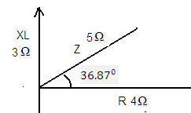
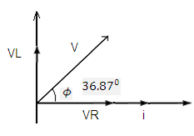

Impedance diagram phasor diagram
Therefore, in the above example current lags voltage by ${36.87}^{0}$
R-C circuit
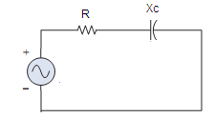

Fig 4.12 RC circuit
In RC circuit the total impedance Z is written as
$$Z=R−jX_{C}∨Z=Z<\tan^{−1}\left(\frac{X_{C}}{R}\right)$$
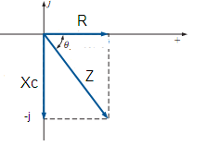
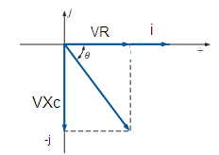

Fig4.9 (a) Impedance diagram (b) phasor diagram
Voltage across resistor(R) and indictor(L) can be determined as
$$V_{R}=i∗Z_{R}$$
$$V_{C}=i∗Z_{C}=i∗X_{C}$$
Thus the total voltage (supply voltage, V_{s})
$V_{s}=V_{R}−jV_{C}$
The total circuit current (I_{T}):
$$i=\frac{V_{s}}{Z}=\frac{V_{R}−jV_{C}}{R−jX_{L}}∨$$
$i=\frac{V_{s}<ϕ_{1}}{Z<{−ϕ}_{2}}=\frac{V_{s}}{Z}<ϕ_{1}+ϕ_{2}$
Example 6. A resistor of 25Ω is connected in series with a capacitor of 45µF. calculate (a) the impedance, (b) the current taken from a 240,50Hz supply. Find also the phase angle between the supply voltage and the current.
a.$capacitivereactance,X_{c}=\frac{1}{2πfC}=\frac{1}{2π\left(50\right)\left(45∗{10}^{−6}\right)}=70.74Ω$
b.$impedanceZ=\sqrt{R^{2}+{X_{C}}^{2}}=\sqrt{{25}^{2}+{70.74}^{2}}=75.03Ω$
c.$current,i=\frac{V}{Z}=\frac{240V}{75.03Ω}=3.2A$
phase angle between the supply voltage and current $ϕ=\tan^{−1}\frac{X_{C}}{R}=\frac{70.74}{25}={70.54}^{0}leading$.
I.e., current leads supply voltage by ${70.54}^{0}$
Series RLC circuit
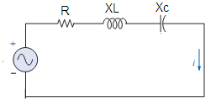

Fig 4.13 RLC circuit
In RLC circuit the total impedance Z written as
$$Z_{T}=Z_{R}+Z_{L}+Z_{C}=R+jX_{L}−jX_{C}$$
$$Z_{T}=R+j\left(X_{L}−X_{C}\right)$$
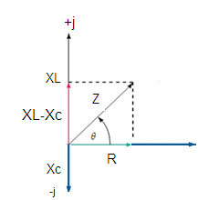
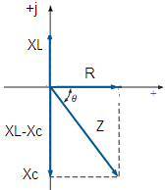

Fig 4.14 (a) Impedance diagram ($forX_{L}>X_{C}$) (b) impedance diagram (for$X_{L}<X_{C}$)

Voltage across each circuit element
$V_{R}=i∗R,V_{C}=i∗X_{C}∧$ $V_{L}=i∗X_{L}$
Where $i=\frac{V_{s}}{Z}$And $V_{s}=V_{R}+j\left(V_{L}−V_{C}\right)$
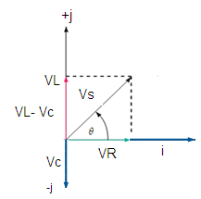
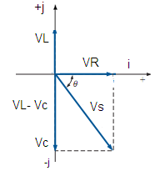

Fig4.15 (a) Phasor diagram(for $X_{L}>X_{C}$) (b) phasor diagram (for$X_{L}<X_{C}$ )

Example 7. A 5Ω resistor, 120mH inductor and 100µF capacitor are connected in series to a 300V, 50Hz AC supply. Calculate (a) the current flowing, (b) the phase difference between the supply voltage and current,(c) the voltage across the circuit elements, and (d) draw the phasor and impedance diagram.
$$X_{L}=2πfL=2π\left(50\right)\left(120∗{10}^{−3}\right)=37.70Ω$$
$$X_{C}=\frac{1}{2πfC}=\frac{1}{2π\left(50\right)\left(100∗{100}^{−6}\right)}=31.83Ω$$
Since X_{L} is greater than X_{C} the circuit is inductive
$$X_{L}−X_{C}=37.7−31.83=5.87Ω$$
$$impedanceZ=\sqrt{R^{2}+{\left(X | | L−X_{C}\right)}^{2}=\sqrt{5^{2}+{5.87}^{2}}=7.71Ω}$$
- $$currenti=\frac{v}{z}=\frac{300}{7.71}=38.91A$$
- $$phaseangleϕ=\tan^{−1}\left(\frac{X_{L−X_{C}}}{R}\right)=\tan^{−1}\left(\frac{5.87}{5}\right)={49.58}^{0}$$
- $$V_{R}=i∗R=38.91A∗5Ω=194.55V$$
$$V_{L}=i∗X_{L}=38.91∗37.7=1466.9V$$
$V_{C}=i∗X_{C}=38.91∗31.83Ω=1238.5V$
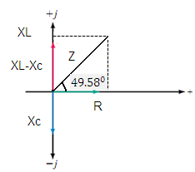
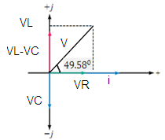

d.

Impedance triangle phasor diagram
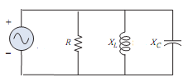
Parallel RLC circuit

Fig 4.13 RLC circuit
Admittance
Admittance is defined as a vector quantity which is the reciprocal of the impedance Z.
Mathematically, admittance is expressed as:
$Y_{T}=\frac{1}{Z_{T}}=\frac{1}{Z_{T<θ}}=\left(\frac{1}{Z_{T}}\right)<−θ=Y_{T}−θ$ the unit of admittance is the Siemens(S).
The admittance of resistor R is called conductance and is given a symbol Y_{R}.
$Y_{R}=\frac{1}{R<0^{0}}=G<0^{0}=G+j0$
The admittance of a purely reactive component X is called susceptance of the component and is assigned the symbol B. The unit for susceptance is Siemens (S).
In order to distinguish between inductive susceptance and capacitive susceptance, we use the subscripts L and C respectively.
$$Y_{L}=\frac{1}{X_{L}<{90}^{0}}=\frac{1}{X_{L}}<−{90}^{0}=B_{L}<−{90}^{0}=0−jB_{L}$$
$$Y_{C}=\frac{1}{X_{C}<−{90}^{0}}=\frac{1}{X_{C}}<{90}^{0}=B_{C}<{90}^{0}=0+jB_{C}$$
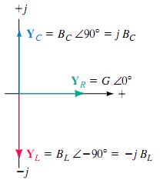

Fig Admittance diagram
The total impedance (Z_{T}) in parallel RLC circuit can be calculated as
$$\frac{1}{Z_{T}}=\frac{1}{Z_{R}}+\frac{1}{Z_{L}}+\frac{1}{Z_{C}}$$
$Y_{T}=Y_{R}+Y_{L}+Y_{C}$
$$Z_{T}=\frac{1}{Y_{T}}$$
The total current (i_{T})
$i_{T}=\frac{V_{s}}{Z_{T}}=V_{s}∗Y_{T}$

Exercise 2
1. Calculate the current taken by 23µF capacitor when connected to a 240 V, 50 Hz supply.
2. A coil has an inductance of 40mH and negligible resistance. Calculate its inductive reactance and the resulting current if connected to(a) a240 V,50Hz supply and (b) a 100 V,1kHz supply.
3. a coil of inductance 300mH and negligible resistance is connected I series with 100Ω resistor to a 250V, 50Hz supply. Calculate (a) the inductive reactance of the coil, (b) the impedance of the circuit,(c) the current in the circuit, (d) voltage across each components and (e) the circuit phase phase angle.
4. A capacitor C is connected in series with a 40Ω resistor across a supply of frequency 60Hz. A current of 3A flows and circuit impedance is 50Hz. Calculate (a) the value of capacitance, C, (b) the supply voltage,(c) the phase angle between the supply voltage and current ,(d) voltage across the resistor and capacitor ,and (e) draw phasor and impedance diagram.
5.A 40µF capacitor in series with a coil of resistance 8Ω and inductance 80mH is connected to a 200V, 100Hz supply. Calculate (a) the circuit impedance,(b) the current flowing, (c) the phase angle between voltage and current, (d) the voltage across the coil, and the resistor,(e) the voltage across the capacitor, and (f) draw the phasor and impedance diagram.

Frequency response
As we have already seen, the reactance of inductors and capacitors depends on frequency. Consequently, the total impedance of any network having reactive elements is also frequency dependent.
Effect of frequency in RC circuit
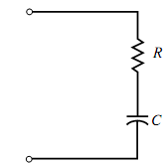

Consider the RC series circuit of the fig 4.15. Recall that the capacitive reactance, X_{C} is given as
$$X_{c}=\frac{1}{ωC}=\frac{1}{2πfC}$$
The total impedance of the circuit is a vector quantity expressed as
$$Z_{T}=R−j\frac{1}{ωC}=R+\frac{1}{jωC}$$
$$Z_{T}=\frac{1+jωRC}{jωC}$$
If we define the cutoff or corner frequency for an RC circuit as$ω_{C}=\frac{1}{RC}$
$equivalentlyasf_{c}=\frac{1}{2πfC}Hz$
Then several important points become evident.
$forω≤\frac{ω_{c}}{10}\left(f≤\frac{f_{C}}{10}\right)thetotalimpedancecanbeexpressedas$
$$Z_{T}=\frac{1+j0}{jωC}=\frac{1}{jωC}$$
$$forω≥10ω_{C}Z_{T}canbesimplifiedas$$
$$Z_{T}=\frac{0+jωRC}{jωC}=R$$

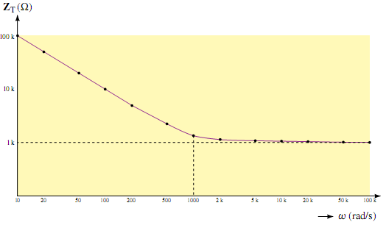
If the magnitude of the impedance Z_{T} plotted as a function of angular frequency ω, we get the graph of fig 4.16.

Fig4.16 Impedance versus angular frequency of RC circuit
The graph illustrates that the reactance of a capacitor is very high (effectively an open circuit) at low frequencies. Consequently, the total impedance of the series circuit will also be very high at low frequencies. Secondly, we notice that as the frequency increases, the reactance decreases .therefore, as the frequency gets higher, the capacitive reactance has a diminished effect in the circuit.
Effect of frequency in RL circuit
RL circuits may be analyzed in a manner similar to the analysis of RC circuits. Consider the parallel RL circuit.
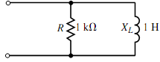

The total impedance of the parallel circuit is found as follows:
$$Z_{T}=\frac{Z_{R}Z_{L}}{Z_{R}+Z_{L}}=\frac{R\left(jωL\right)}{R+jωL}=\frac{jωL}{1+jω\frac{L}{R}}$$

If we define the cutoff or corner frequency for an RL circuit as $ω_{C}=\frac{R}{L}$
$equivalentasf_{C}=\frac{1}{2πL}$
Then several important points become evident.
$$forω≤\frac{ω_{c}}{10}\left(f≤\frac{f_{C}}{10}\right)thetotalimpedancecanbeexpressedas$$
$$Z_{T}=\frac{jωL}{1+j0}=jωL$$
The above result indicates that for low frequencies, the inductor has a very small reactance, resulting in total impedance which is essentially equal to the inductive reactance.
$$forω≥10ω_{C}Z_{T}canbesimplifiedas$$
$$Z_{T}=\frac{jωL}{0+jω\frac{L}{R}}=R$$
The above results indicate that for high frequencies, the impedance of the circuit is essentially equal to the resistance, due to the very high impedance of the inductor.
When the magnitude of the impedance Z_{T} is plotted as a function of angular frequency ω we get the graph
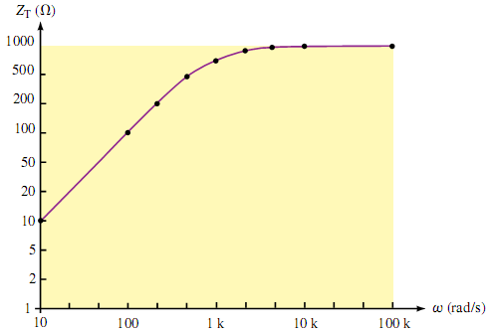

Fig 4.17 Impedance versus angular frequency for the parallel RL circuit

Resonance circuits
1.Series Resonance
The most prominent feature of the frequency response of a circuit may be the sharp peak (or resonant peak) exhibited in its amplitude characteristic. The concept of resonance applies in several areas of science and engineering. Resonance occurs in any system that has a complex conjugate pair of poles; it is the cause of oscillations of stored energy from one form to another. It is the phenomenon that allows frequency discrimination in communications networks. Resonance occurs in any circuit that has at least one inductor and one capacitor.

Resonance is a condition in an RLC circuit in which the capacitive and inductive reactance are equal in magnitude, thereby resulting in a purely resistive impedance.

Consider the series RLC circuit shown in Fig. 4.18 in the frequency domain.

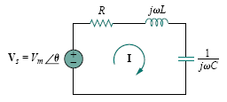

Fig 4.18 the series resonant circuit.

The input impedance is
$$Z=H\left(ω\right)=\frac{V_{s}}{I}=R+jωL+\frac{1}{jωC}$$

$Z=R+j\left(ωL−\frac{1}{jωC}\right)$

Resonance results when the imaginary part of the transfer function is zero, or

$$ℑ\left(Z\right)=ωL−\frac{1}{ωC}=0$$

The value of ω that satisfies this condition is called the resonant frequency ω0. Thus, the resonance condition is
$$ωoL=\frac{1}{ωoC}$$
or
$$ωo=\frac{1}{\sqrt{LC}}{rad}/{sec}$$

Since ω0 = 2πf0,
$$f_{0}=\frac{1}{2π\sqrt{LC}}Hz$$
The frequency response of the circuit’s current magnitude

$$I=I/{}\frac{V_{m}}{\sqrt{R^{2}+{\left(ωL−1/{ωC}\right)}^{2}}}$$
is shown in Fig. 4.19; the plot only shows the symmetry illustrated in this graph when the frequency axis is a logarithm.

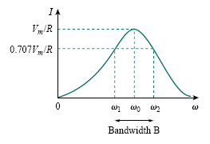

Fig 4.19 The current amplitude versus frequency for the series resonant circuit of Fig. 4.18.

The average power dissipated by the RLC circuit is

$$p\left(ω\right)=\frac{1}{2}I^{2}R$$
The highest power dissipated occurs at resonance, when I = V m / R , so that

$$p\left(ωo\right)=\frac{1}{2}\frac{{V_{m}}^{2}}{R}$$

At certain frequencies ω = ω1, ω2, the dissipated power is half the maximum value; that is,
$P\left(ω1\right)=P\left(ω2\right)=\frac{{\left({V_{m}}/{\sqrt{2}}\right)}^{2}}{2R}=\frac{{Vm}^{2}}{4R}$

Hence, ω1 and ω2 are called the half-power frequencies.
The half-power frequencies are obtained by setting Z equal to√2R, and writing

$$\sqrt{R^{2}+{\left(ωL−\frac{1}{ωC}\right)}^{2}}=\sqrt{2}R$$

Solving for ω, we obtain

$$ω_{1}=\frac{−R}{2L}+\sqrt{{\left(\frac{R}{2L}\right)}^{2}+\frac{1}{LC}}$$

$$ω_{1}=\frac{R}{2L}+\sqrt{{\left(\frac{R}{2L}\right)}^{2}+\frac{1}{LC}}$$
We can relate the half-power frequencies with the resonant frequency.

$$ω_{0}=\sqrt{ω_{1}ω_{2}}$$

showing that the resonant frequency is the geometric mean of the half power frequencies. Notice that ω1 and ω2 are in general not symmetrical around the resonant frequency ω0, because the frequency response is not generally symmetrical. However, as will be explained shortly, symmetry of the half-power frequencies around the resonant frequency is often a reasonable approximation.
Although the height of the curve in Fig. 4.19 is determined by R, the width of the curve depends on other factors. The width of the response curve depends on the bandwidth B, which is defined as the difference between the two half-power frequencies,
$$B=ω_{2}{−ω}_{1}$$

Quality factor
The “sharpness” of the resonance in a resonant circuit is measured quantitatively by the quality factor Q. At resonance, the reactive energy in the circuit oscillates between the inductor and the capacitor. The quality
factor relates the maximum or peak energy stored to the energy dissipated in the circuit per cycle of oscillation:

$$Q=2π\frac{peakenergystored∈thecircuit}{Energydissipatedbythecircuit∈oneperiodatresonane}$$

It is also regarded as a measure of the energy storage property of a circuit in relation to its energy dissipation property. In the series RLC circuit, the peak energy stored is $\frac{1}{2}LI^{2}$, while the energy dissipated in one period
is.
$$\frac{1}{2}\left(I^{2}R\right)\left(\frac{1}{f}\right)$$

Hence, $Q=2π\frac{\frac{1}{2}LI^{2}}{\frac{1}{2}I^{2}R\left(\frac{1}{f}\right)}=\frac{2πfC}{R}$
or
$$Q=\frac{ωoL}{R}=\frac{1}{ωoCR}$$

Notice that the quality factor is dimensionless. The relationship between the bandwidth B and the quality factor Q is obtained by

$B=\frac{R}{L}=\frac{ωo}{Q}$
or
$B={ω_{o}}^{2}CR$ thus,

The quality factor of a resonant circuit is the ratio of its resonant frequency to its bandwidth.

As illustrated in Fig. below the higher the value of Q, the more selective the circuit is but the smaller the bandwidth. The selectivity of an RLC circuit is the ability of the circuit to respond to a certain frequency and discriminate against all other frequencies. If the band of frequencies to be selected or rejected is narrow, the quality factor of the resonant circuit must be high. If the band of frequencies is wide, the quality factor must be low.
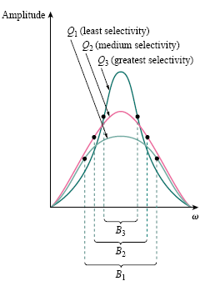
Fig 4.20 The higher the circuit Q, the smaller the bandwidth.

A resonant circuit is designed to operate at or near its resonant frequency. It is said to be a high -Q circuit when its quality factor is equal to or greater than 10. For high -Q circuits (Q ≥ 10), the half power frequencies are, for all practical purposes, symmetrical around the resonant frequency and can be approximated as

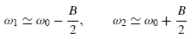

Example:8
In the circuit in Fig. below, R = 2 &, L = 1 mH, and C = 0.4 μF.
(a) Find the resonant frequency and the half-power frequencies.
(b) Calculate the quality factor and bandwidth.
(c) Determine the amplitude of the current at ω0, ω1, and ω2.

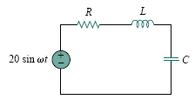

Solution:
- The resonant frequency is
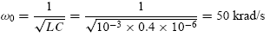

The lower half-power frequency is
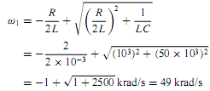

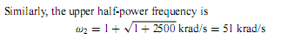

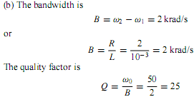

Method 2 Alternatively, we could find
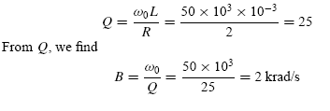

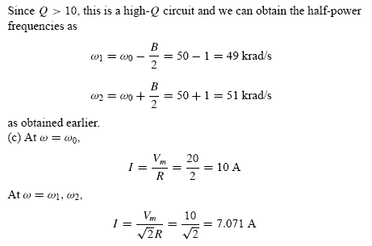

PARALLEL RESONANCE
The parallel RLC circuit in Fig. 14.25 is the dual of the series RLC circuit. So we will avoid needless repetition.

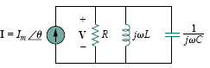
Fig 4.21 The parallel resonant circuit.
The admittance is
Y = $H\left(ω\right)=$I / V =$\frac{1}{R}+jωC+\frac{1}{jωL}$
Or
Y = $H\left(ω\right)=\frac{1}{R}+j\left(ωC−\frac{1}{ωL}\right)$

Resonance occurs when the imaginary part of Y is zero,
$$ωC−\frac{1}{ωL}=0$$
Or
$ω_{o}=\frac{1}{\sqrt{LC}}{rad}/s$
The voltage |V| is sketched in Fig. 14.26 as a function of frequency. Notice that at resonance, the parallel LC combination acts like an open circuit, so that the entire currents flows through R.
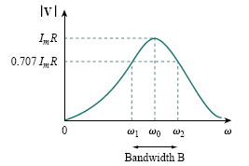
Fig 4.22 The current amplitude versus frequency for the series resonant circuit of Fig. 4.21

By replacing R, L, and C in the expressions for the series circuit with 1/R, 1/C, and 1/L respectively, we obtain for the parallel circuit
$$ω_{1}=\frac{−1}{2RC}+\sqrt{{\left(\frac{1}{2RC}\right)}^{2}+\frac{1}{LC}}$$
$ω_{2}=\frac{1}{2RC}+\sqrt{{\left(\frac{1}{2RC}\right)}^{2}+\frac{1}{LC}}$
$$B=ω_{2}−ω_{1}=\frac{1}{RC}$$
$$Q=\frac{ω_{o}}{B}=ω_{o}RC=\frac{R}{ω_{0}L}$$

we can express the half-power frequencies in terms of the quality factor. The result is
$ω_{1}=ω_{o}\sqrt{1+{\left(\frac{1}{2Q}\right)}^{2}}$ $\frac{−ω_{o}}{2Q}$ , $ω_{2}=ω_{o}\sqrt{1+{\left(\frac{1}{2Q}\right)}^{2}}$ $\frac{+ω_{o}}{2Q}$

Again, for high-Q circuits (Q ≥ 10)
$$ω_{1}≅ω_{o}−\frac{B}{2},ω_{2}≅ω_{o}+\frac{B}{2}$$

Summary of the characteristics of resonant RLC circuits.

Characteristic Series circuit Parallel circuit
Resonant frequency, ω₀ $\frac{1}{\sqrt{LC}}$ $\frac{1}{\sqrt{LC}}$
Quality factor, Q $\frac{ω_{o}L}{R}∨\frac{1}{ω_{o}RC}$ $\frac{R}{ω_{o}L}∨ω_{o}RC$
Bandwidth, B $\frac{ω_{o}}{Q}$ $\frac{ω_{o}}{Q}$
Half-power frequencies, ω1, ω2 $ω_{o}\sqrt{1+{\left(\frac{1}{2Q}\right)}^{2}}$ $±\frac{ω_{o}}{2Q}$ $ω_{o}\sqrt{1+{\left(\frac{1}{2Q}\right)}^{2}}$ $±\frac{ω_{o}}{2Q}$
For Q ≥ 10, ω1, ω2 $ω_{o}±\frac{B}{2}$ $ω_{o}±\frac{B}{2}$

Example:9
In the parallel RLC circuit shown below, let R = 8 k&, L = 0.2 mH, and C = 8 μF. (a) Calculate ω_{o}, Q, and B. (b) Find ω₁ and ω₂. (c) Determine the power dissipated at ω_{o}, ω₁, and ω₂.
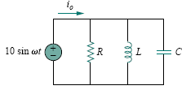
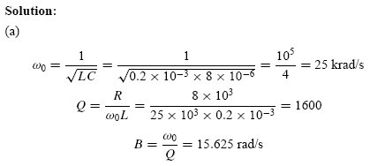
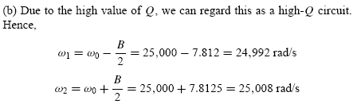
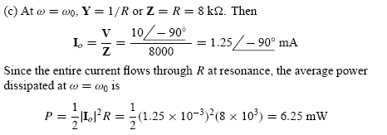
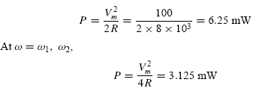

AC powers
INSTANTANEOUS AND AVERAGE POWER
The instantaneous power p(t) absorbed by an element is the product of the instantaneous voltage v(t) across the element and the instantaneous current i(t) through it.

p(t) = v(t)i(t)…………………………………………………………..…………….(4.5.1)

The instantaneous power is the power at any instant of time. It is the rate at which an element absorbs energy.
Let the voltage and current at the terminals of the circuit be
v(t) = Vm cos(ωt + θv……….…………………..……………….(4.5.2)
i(t) = Im cos(ωt + θi)………………………………………………4.5.3)

Where Vm and Im are the amplitudes (or peak values), and θv and θi are the phase angles of the voltage and current, respectively.
The instantaneous power absorbed by the circuit is
$P(t)$= v(t)i(t) = VmIm cos(ωt + θv) cos(ωt + θi)………………..(4.5.4)

We apply the trigonometric identity
$\text{cos}A\text{cos}B=\frac{1}{2}\left[\text{cos}(A−B)+\text{cos}(A+B)\right]$
And express Eq. (4.5.4) as
$p(t)=\frac{1}{2}V_{m}I_{m}\text{cos}(θ_{v}−θ_{i})+\frac{1}{2}V_{m}I_{m}\text{cos}(2\text{wt}+θ_{v}+θ_{i})$…….………… (4.5.6)
This shows us that the instantaneous power has two parts. The first part is constant or time independent. Its value depends on the phase difference between the voltage and the current. The second part is a sinusoidal function whose frequency is 2ω, which is twice the angular frequency of the voltage or current.
A sketch of $P(t)$in Eq. (4.5.6) is shown in Fig below
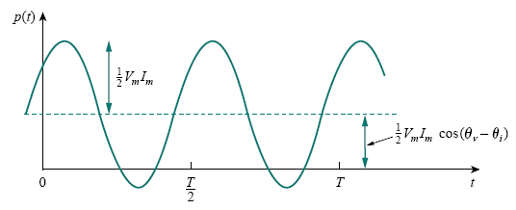
Fig 4.5.1 The instantaneous power $P(t)$entering a circuit.

We also observe that $P(t)$is positive for some part of each cycle and negative for the rest of the cycle. When $P(t)$positive, power is absorbed by the circuit. When$P(t)$is negative, the power is absorbed by the source; that is, power is transferred from the circuit to the source. This is possible because of the storage elements (capacitors and inductors) in the circuit.

Average power
The instantaneous power changes with time and is therefore difficult to measure. The average power is more convenient to measure. In fact, the wattmeter, the instrument for measuring power, responds to average power.
The average power is the average of the instantaneous power over one period.
Thus, the average power is given by

$P(t)=\frac{1}{T}\int_{0}^{T}{p(t)\text{dt}}$………………….………….. (4.5.7)
Substituting $P(t)$in Eq. (4.5.6) into Eq. (4.5.7) gives

$P=\frac{1}{T}\int_{0}^{T}{\frac{1}{2}V_{m}I_{m}}\text{cos}(θ_{v}−θ_{i})\text{dt}+\frac{1}{T}\int_{0}^{T}{\frac{1}{2}V_{m}I_{m}}\text{cos}(2\text{wt}+θ_{v}+θ_{i})\text{dt}$…………….… (4.5.8)

$P=\frac{1}{2}V_{m}I_{m}\text{cos}(θ_{v}−θ_{i})\frac{1}{T}\int_{0}^{T}{\text{dt}}+\frac{1}{2}V_{m}I_{m}\frac{1}{T}\int_{0}^{T}{\text{cos}(2\text{wt}+θ_{v}+θ_{i})}\text{dt}$………………. (4.5.9)
The first integrand is constant, and the average of a constant is the same constant. The second integrand is a sinusoid. We know that the average of a sinusoid over its period is zero because the area under the sinusoid during a positive half-cycle is canceled by the area under it during the following negative half-cycle. Thus, the second term in Eq. (4.5.9) vanishes and the average power becomes
$P=\frac{1}{2}V_{m}I_{m}\text{cos}(θ_{v}−θ_{i})$………………………..… (4.5.10)
Complex power
The phasor forms of $v(t)$ and $i(t)$ in Eq. (4.5.2) and Eq. (4.5.3) are V =$V_{m}∠θ_{v}$ and I =$I_{m}∠θ_{i}$, respectively. P is calculated using Eq. (4.5.10) or using phasors V and I. To use phasors, we notice that
S = $\frac{1}{2}$VI* = V_{rms}I_{rms}* = $\frac{1}{2}V_{m}I_{m}∠(θ_{v}−θ_{i})$……………………….. (4.5.11)
=$\frac{1}{2}V_{m}I_{m}\text{cos}(θ_{v}−θ_{i})+j\frac{1}{2}V_{m}I_{m}\text{sin}(θ_{v}−θ_{i})$

S= $V_{\text{rms}}I_{\text{rms}}\text{cos}(θ_{v}−θ_{i})+{\text{jV}}_{\text{rms}}I_{\text{rms}}\text{sin}(θ_{v}−θ_{i})$...……………………. (4.5.12)

P Q
Apparent power
We notice from Eq. (4.5.11) that the magnitude of the complex power is the apparent power; hence, the complex power is measured in volt-amperes (VA). Also, we notice that the angle of the complex power is the power factor angle. The apparent power is given by
$S=V_{\text{rms}}I_{\text{rms}}$
The complex power maybe expressed in terms of the load impedance Z. The load impedance Z may be written as
$Z=\frac{V}{I}=\frac{V_{\text{rms}}}{I_{\text{rms}}}∠(θ_{v}−θ_{i})$. Z, V, and I in phasor form.
Thus, Vrms = ZIrms. Substituting this into Eq. (4.5.11) gives
S=$I_{\text{rms}}^{2}Z=\frac{V_{\text{rms}}^{2}}{Z^{}}$………………………. (4.5.13)
Since Z = $R+\text{jX}$, Eq. (4.5.13) becomes
S=$I_{\text{rms}}^{2}(R+\text{jX})=P+\text{jQ}$
where P and Q are the real and imaginary parts of the complex power;
that is,
P = $R_{e}$ (S) = $I_{\text{rms}}^{2}R$
Q = Im (S) = $I_{\text{rms}}^{2}X$

Active or real power
The real power P is the average power in watts delivered to a load; it is the only useful power. It is the actual power dissipated by the load. P is the average or real power and it depends on the load’s resistance R. And is given by
P =$V_{\text{rms}}I_{\text{rms}}\text{cos}(θ_{v}−θ_{i})$
Reactive power
The reactive power Q is a measure of the energy exchange between the source and the reactive part of the load. The unit of Q is the volt-ampere reactive (VAR) to distinguish it from the real power, whose unit is the watt. We know that energy storage elements (capacitors and inductors) neither dissipate nor supply power, but exchange power back and forth with the rest of the network. In the same way, the reactive power is being transferred back and forth between the load and the source. It represents a lossless interchange between the load and the source. Notice that:
Q =$V_{\text{rms}}I_{\text{rms}}\text{sin}(θ_{v}−θ_{i})$
1. Q = 0 for resistive loads (unity pf).
2. Q < 0 for capacitive loads (leading pf).
3. Q > 0 for inductive loads (lagging pf).

Summary
Complex Power = S = $P+\text{jQ}=\frac{1}{2}$VI*
= $V_{\text{rms}}I_{\text{rms}}∠θ_{v}−θ_{I}$
Apparent Power = S = S = $V_{\text{rms}}I_{\text{rms}}=\sqrt{P^{2}+Q^{2}}$
Real Power = P = Re(S) = S cos($θ_{v}−θ_{i}$)
Reactive Power = Q = Im(S) = S sin($θ_{v}−θ_{i}$)
Power Factor = $\frac{P}{S}=\text{cos}(θ_{v}−θ_{i})$

Power triangle
It is a standard practice to represent S, P, and Q in the form of a triangle, known as the power triangle, shown in Fig. 4.5.2(a). This is similar to the impedance triangle showing the relationship between Z, R, and X, illustrated in Fig. 4.5.2(b). The power triangle has four items—the apparent/complex power, real power, reactive power, and the power factor angle. Given two of these items, the other two can easily be obtained from the triangle.
As shown in Fig. 4.5.3, when S lies in the first quadrant, we have an inductive load and a lagging pf. When S lies in the fourth quadrant, the load is capacitive and the pf is leading.

Fig 4.5.2 (a) power triangle (b) Impedance triangle

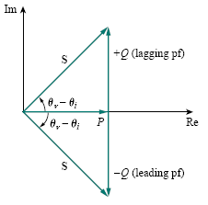

Fig 4.5.3 power triangle
Power factor correction
Most domestic loads (such as washing machines, air conditioners, and refrigerators) and industrial loads (such as induction motors) are inductive and operate at a low lagging power factor. Although the inductive nature of the load cannot be changed, we can increase its power factor.

The process of increasing the power factor without altering the voltage or current to the original load is known as power factor correction.
Alternatively, power factor correction may be viewed as the addition of a reactive element (usually a capacitor) in parallel with the load in order to make the power factor closer to unity
.
Since most loads are inductive, as shown in Fig. 4.6.1(a), a load’s power factor is improved or corrected by deliberately installing a capacitor in parallel with the load, as shown in Fig. 4.6.1(b). The effect of adding the capacitor can be illustrated using either the power triangle or the phasor diagram of the currents involved. Figure 4.6.2 shows the latter, where it is assumed that the circuit in Fig. 4.6.1(a) has a power factor of cos θ1, while the one in Fig. 4.6.1(b) has a power factor of cos θ2.
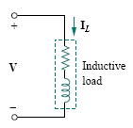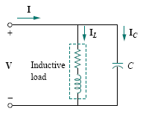
Fig. 4.6.1 Power factor correction: (a) original inductive load,
(b) Inductive load with improved power factor.
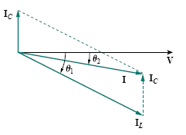

Fig. 4.6.2 Phasor diagram showing the effect of adding a capacitor in parallel with the inductive load.

It is evident from Fig. 4.6.2 that adding the capacitor has caused the phase angle between the supplied voltage and current to reduce from $θ_{1}$ to $θ_{2}$, thereby increasing the power factor. We also notice from the magnitudes of the vectors in Fig. 4.6.2 that with the same supplied voltage, the circuit in Fig. 4.6.1(a) draws larger current $I_{L}$than the current I drawn by the circuit in Fig. 4.6.1(b). Power companies charge more for larger currents, because they result in increased power losses (by a squared factor, since$P=I^{2}R$). Therefore, it is beneficial to both the power company and the consumer that every effort is made to minimize current level or keep the power factor as close to unity as possible. By choosing a suitable size for the capacitor, the current can be made to be completely in phase with the voltage, implying unity power factor.

We can look at the power factor correction from another perspective. Consider the power triangle in Fig. 4.6.3. If the original inductive load has apparent power S1, then

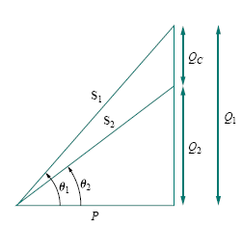
Fig 4.6.3 Power triangle illustrating power factor correction.

$P=S_{1}\text{cos}θ_{1}$ ,$Q_{1}=S_{1}\text{sin}θ_{1}=P\text{tan}θ_{1}$ …………………….……………. (4.6.1)
If we desire to increase the power factor from cos $θ_{1}$ to cos $θ_{2}$ without altering the real power (i.e.$P=S_{2}\text{cos}θ_{2}$), then the new reactive power is
$Q_{2}=P\text{tan}θ_{2}$ …………………………………… (4.6.2)
The reduction in the reactive power is caused by the shunt capacitor, that is,
$Q_{C}=Q_{1}−Q_{2}=P(\text{tan}θ_{1}−\text{tan}θ_{2})$ ……………………………………….. (4.6.3)
Since $Q_{C}=V_{\text{rms}}^{3}/X_{C}=ω{\text{CV}}_{\text{rms}}^{2}$ The value of the required shunt capacitance C is determined as
$C=\frac{Q_{C}}{{ωV}_{\text{rms}}^{2}}=\frac{P(\text{tan}θ_{1}−\text{tan}θ_{2})}{{ωV}_{\text{rms}}^{2}}$ ………………………..…….. (4.6.4)
Note that the real power P dissipated by the load is not affected by the power factor correction because the average power due to the capacitance is zero. Although the most common situation in practice is that of an inductive load, it is also possible that the load is capacitive, that is, the load is operating at a leading power factor. In this case, an inductor should be connected across the load for power factor correction. The required shunt inductance L can be calculated from
$Q_{L}=\frac{V_{\text{rms}}^{2}}{X_{L}}=\frac{V_{\text{rms}}^{2}}{ωL}$ , $L=\frac{V_{\text{rms}}^{2}}{{ωQ}_{L}}$……………………(4.6.5) where$Q_{L}=Q_{1}−Q_{2}$, the difference between the new and old reactive powers.

Example:
When connected to a 120 V (rms), 60-Hz power line, a load absorbs 4 kW at a lagging power factor of 0.8. Find the value of capacitance necessary to raise the pf to 0.95.
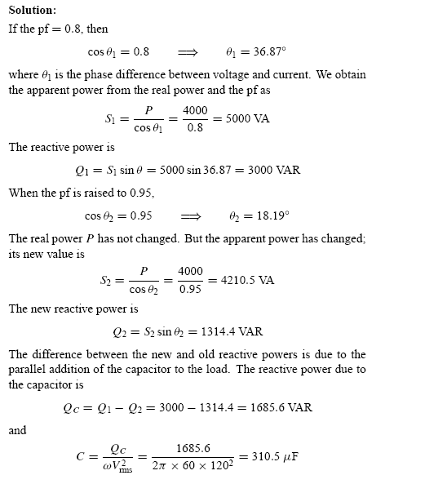

In this chapter, we want to see how nodal analysis, mesh analysis, Thevenin’s theorem, Norton’s theorem, superposition, and source transformations are applied in analyzing ac circuits. Since these techniques were already introduced for dc circuits, our major effort here will be to illustrate with examples.
Analyzing ac circuits usually requires three steps.
Steps to analyze AC circuits:
1. Transform the circuit to the phasor or frequency domain.
2. Solve the problem using circuit techniques (nodal analysis, mesh analysis, superposition, etc.).
3. Transform the resulting phasor to the time domain.
Mesh Analysis
Kirchhoff’s voltage law (KVL) forms the basis of mesh analysis. The validity of KVL for ac circuits is illustrated in the following examples.
Example 1
Determine current Io in the circuit given below using mesh analysis.

Fig. 4.7.1
Applying KVL to mesh 1, we obtain
$(8+j\text{10}−j2)I_{1}−(−j2)I_{2}−j\text{10}I_{3}=0$ ……………..………………………. (4.7.1)
For mesh 2,
$(4−j2−j2)I_{2}−(−j2)I_{1}−(−j2)I_{3}+\text{20}∠{\text{90}}^{o}=0$…...……………………….. (4.7.2)
For mesh 3, $I_{3}=5\text{.}$
Substitute this in equation 4.7.1 and 4.7.2. We get
$\begin{aligned}(8+j8)I_{1}+j2I_{2}=j\text{50} \\ j2I_{1}+(4−j4)I_{2}=−j\text{20}−j\text{10}\end{aligned}$
The above equations can be put in matrix form
$\begin{aligned}[8+j8 \\ [j2\end{aligned}[$ $\begin{aligned}j2 \\ ]4−j4 \\ \end{aligned}]$$\begin{aligned}\left[I_{1} | \right] \\ \end{aligned}$=$\begin{aligned}\left[j\text{50} | \right] \\ \end{aligned}$
From which we obtain the determinants

$Δ=\begin{aligned}|8+j8 \\ |j2\end{aligned}$ $\begin{aligned}j2 \\ |4−j4 \\ \end{aligned}$=32(1 + j) (1− j) + 4 = 68
$Δ_{2}=\begin{aligned}|8+j8 \\ |j2\end{aligned}$ $\begin{aligned}j\text{50} \\ |−j\text{30} \\ \end{aligned}$ = 340 – j240 = 416.17$∠−\text{35}\text{.}{\text{22}}^{o}$
$$I_{2}=\frac{Δ_{2}}{Δ}=\frac{\text{416}\text{.}\text{17}∠−\text{35}\text{.}{\text{22}}^{o}}{\text{68}}=6\text{.}\text{12}∠−\text{35}\text{.}{\text{22}}^{o}A$$
The desired current is
$I_{o}=−I_{2}=6\text{.}\text{12}∠\text{144}\text{.}{\text{78}}^{o}A$
Example 2
Solve for $V_{o}$in the circuit given below using mesh analysis.

Fig. 4.7.2
Solution:
As shown in figure 4.7.3 meshes 3 and 4 form a supermesh due to the current source between the meshes. For mesh 1 KVL
$−\text{10}+(8−j2)I_{1}−(−j2)I_{2}−8I_{3}=0$ ……………………… (4.7.3)
Or
$(8−j2)I_{1}+j2I_{2}−8I_{3}=\text{10}$……..……………… (4.7.4)
For mesh 2,
$I_{2}=−3$…………………….………….…….. (4.7.5)
For the supermesh,
$(8−j4)I_{3}−8I_{1}+(6+j5)I_{4}−j5I_{2}=0$……………….…… (4.7.6)
Due to the current source between meshes 3 and 4, at node A,
$I_{4}=I_{3}+4$ ……………..……………. (4.7.7)
Combining Equation 4.7.4 and 4.7.5
$(8−j2)I_{1}−8I_{3}=\text{10}+j6$……………………………….… (4.7.8)
Combining Equations 4.7.6 and 4.7.7
$−8I_{1}+(\text{14}+j)I_{3}=−\text{24}−j\text{35}$………… ……………………. (4.7.9)

Fig.4.7.3
From Equations (4.7.8) and (4.7.9), we obtain the matrix equation
$\begin{aligned}[8−j2 \\ [−8\end{aligned}[$ $\begin{aligned}−8 \\ ]\text{14}+j \\ \end{aligned}]$$\begin{aligned}\left[I_{1} | \right] \\ \end{aligned}$=$\begin{aligned}\left[\text{10}+j6 | \right] \\ \end{aligned}$
We obtain the following determinants
$Δ=\begin{aligned}|8−j2 \\ |−8\end{aligned}$ $\begin{aligned}−8 \\ |\text{14}+j \\ \end{aligned}=\text{112}+j8+−j\text{28}+2−\text{64}=\text{50}−j\text{20}$

$Δ_{1}=\begin{aligned}|\text{10}+j6 \\ |−\text{24}−j\text{35}\end{aligned}$ $\begin{aligned}−8 \\ |\text{14}+j \\ \end{aligned}$= $\text{140}+j\text{10}+j\text{84}−6−\text{192}−j\text{280}$
$=−\text{58}−j\text{186}$
Current I1 is obtained as
$I_{1}=\frac{Δ_{1}}{Δ}=\frac{−\text{58}−j\text{186}}{\text{50}−j\text{20}}=3\text{.}\text{618}∠\text{274}\text{.}5^{o}A$
The required voltage $V_{o}$ is
$V_{o}=−j2(I_{1}−I_{2})=−j(3\text{.}\text{618}∠\text{274}\text{.}5^{o}+3)$
$=−7\text{.}\text{2134}−j6\text{.}\text{568}=9\text{.}\text{756}∠\text{222}\text{.}{\text{32}}^{o}V$

Exercise
Calculate current $I_{o}$ in the circuit given below

Fig. 4.7.4
Answer: $5\text{.}\text{075}∠5\text{.}{\text{943}}^{o}A$

Nodal analysis
The basis of nodal analysis is Kirchhoff’s current law. Since KCL is valid for phasors, we can analyze ac circuits by nodal analysis. The following examples illustrate this.
Example 1
Find $I_{x}$ in the circuit given below using nodal analysis.
Fig. 4.7.5
Solution:
We first convert the circuit to the frequency domain:
$\text{20}\text{cos}4t$ $⇒$ $\text{20}∠0^{o}$, $ω=4{\text{rad}}/s$
1H $⇒$ $jωL=j4$
0.5H $⇒$ $jωL=j2$
0.1F $⇒$ $\frac{1}{jωC}=−j2\text{.}5$
Thus the frequency equivalent circuit is as shown below

Fig 4.7.6
Applying KCL at node 1,
$\frac{\text{20}−V_{1}}{\text{10}}=\frac{V_{1}}{−j2\text{.}5}+\frac{V_{1}−V_{2}}{j4}$
Or
$(1+j1\text{.}5)V_{1}+j2\text{.}5V_{2}=\text{20}\text{.}\text{.}\text{.}\text{.}\text{.}\text{.}\text{.}\text{.}\text{.}\text{.}\text{.}\text{.}\text{.}\text{.}\text{.}\text{.}\text{.}\text{.}\text{.}\text{.}\text{.}\text{.}\text{.}\text{.}\text{.}\text{.}\text{.}\text{.}\text{.}\text{.}\text{.}\text{.}\text{.}\text{.}\text{.}(∗)$
At node 2
$2I_{X}+\frac{V_{1}−V_{2}}{j4}=\frac{V_{2}}{j2}$
But $I_{X}=\frac{V_{1}}{−j2\text{.}5}$ substituting this gives
$\frac{2V_{1}}{−j2\text{.}5}+\frac{V_{1}−V_{2}}{j4}=\frac{V_{2}}{j2}$
By simplifying, we get
$\text{11}V_{1}+\text{15}V_{2}=0\text{.}\text{.}\text{.}\text{.}\text{.}\text{.}\text{.}\text{.}\text{.}\text{.}\text{.}\text{.}\text{.}\text{.}\text{.}\text{.}\text{.}\text{.}\text{.}\text{.}\text{.}\text{.}\text{.}\text{.}\text{.}\text{.}\text{.}\text{.}\text{.}\text{.}\text{.}\text{.}\text{.}\text{.}\text{.}\text{.}\text{.}\text{.}\text{.}\text{.}\text{.}(\text{**})$

Equations (*) and (**) can be put in matrix form as
$\begin{aligned}[1+j1\text{.}5 \\ [\text{11}\end{aligned}[$ $\begin{aligned}j2\text{.}5 \\ ]\text{15} \\ \end{aligned}]$$\begin{aligned}\left[V_{1} | \right] \\ \end{aligned}$=$\begin{aligned}\left[\text{20} | \right] \\ \end{aligned}$
We determine the determinants as
$Δ=\begin{aligned}|1+j1\text{.}5 \\ |\text{11}\end{aligned}$ $\begin{aligned}j2\text{.}5 \\ |\text{15} \\ \end{aligned}$=$\text{15}−j5$
$Δ_{1}=\begin{aligned}|\text{20} \\ |0\end{aligned}$ = 300
$Δ_{2}=\begin{aligned}|1+j1\text{.}5 \\ |\text{11}\end{aligned}$ $\begin{aligned}\text{20} \\ |0 \\ \end{aligned}=−\text{220}$
$$V_{1}=\frac{Δ_{1}}{Δ}=\frac{\text{300}}{\text{15}−j5}=\text{18}\text{.}\text{97}∠\text{18}\text{.}{\text{43}}^{0}V$$
$$V_{2}=\frac{Δ_{2}}{Δ}=\frac{−\text{220}}{\text{15}−j5}=\text{13}\text{.}\text{91}∠\text{198}\text{.}3^{o}V$$
The current Ix is given by
Ix = $\frac{V_{1}}{−j2\text{.}5}=\frac{\text{18}\text{.}\text{97}∠\text{18}\text{.}{\text{43}}^{o}}{2\text{.}5∠−{\text{90}}^{o}}=7\text{.}\text{59}∠\text{108}\text{.}4^{o}A$
Transforming this to time domain
$i_{X}=7\text{.}\text{59}\text{cos}(4t+\text{108}\text{.}4^{o})A$

Exercise:
Using nodal analysis find $V_{1}$ and $V_{2}$ in the circuit below
Fig. 4.7.7
Answer: $V_{1}(t)=\text{20}\text{.}\text{96}\text{sin}(2t+{\text{58}}^{o})V,V_{2}(t)=\text{44}\text{.}\text{11}(2t+{\text{41}}^{o})V$
Example 2
Compute V1 and V2 in the circuit of Fig. below
Fig. 4.7.8
Solution:
Nodes 1 and 2 form a supernode as shown below. Applying KCL at the supernode gives

$3=\frac{V_{1}}{−j3}+\frac{V_{2}}{j6}+\frac{V_{2}}{\text{12}}$
Or
$\text{36}=j4V_{1}+(1−j2)V_{2}$…………………………………… (4.7.10)
But a voltage source is connected between nodes 1 and 2, so that
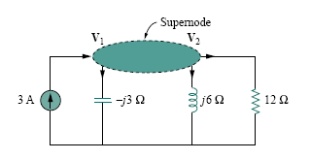
Fig. 4.7.9
$V_{1}=V_{2}+\text{10}∠{\text{45}}^{o}$……………………………………………. (4.7.11)

Substituting Eq. (4.7.11) in Eq. (4.7.10) results in
$\text{36}−\text{40}∠{\text{135}}^{o}=(1+j2)V_{2}$
$V_{2}=\text{31}\text{.}\text{41}∠−\text{87}\text{.}{\text{18}}^{o}V$
From Eq. (4.7.11),
$V_{1}=V_{2}+\text{10}∠{\text{45}}^{o}=\text{25}\text{.}\text{78}V$
Exercise 2
Calculate V1 and V2 in the circuit shown below

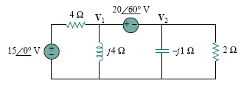
Fig.4.7.10
Answer: V1= $\text{19}\text{.}\text{36}∠\text{69}\text{.}{\text{67}}^{o}$V, V2 = $3\text{.}\text{376}∠\text{165}\text{.}7°$V
Superposition
Since ac circuits are linear, the superposition theorem applies to ac circuits the same way it applies to dc circuits. The theorem becomes important if the circuit has sources operating at different frequencies. In this case, since the impedances depend on frequency, we must have a different frequency-domain circuit for each frequency. The total response must be obtained by adding the individual responses in the time domain. It is incorrect to try to add the responses in the phasor or frequency domain. Why? Because the exponential factor $e^{\text{jwt}}$ is implicit in sinusoidal analysis, and that factor would change for every angular frequency$w$. It would therefore not make sense to add responses at different frequencies in the phasor domain. Thus, when a circuit has sources operating at different frequencies, one must add the responses due to the individual frequencies in the time domain.

Example
Use the superposition theorem to find Io in the circuit in figure below
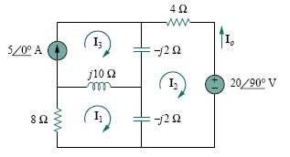
Fig. 4.7.11

Solution:
Let
$I_{o}=I_{o}^{'}+I_{o}^{\text{''}}$ …………………………………….………….. (4.7.12)
Where $I_{o}^{'}$ and $I_{o}^{\text{''}}$ are due to the voltage and current sources, respectively.
Consider the circuit below
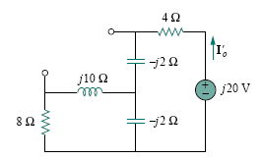
Fig. 4.7.12
If we let Z the parallel combination of $−j2$ and $8+j\text{10}$ , then
Z = $\frac{−j2(8+j\text{10})}{−j2+8+j\text{10}}=0\text{.}\text{25}−j2\text{.}\text{25}$
And current $I_{o}^{'}$ is
$I_{o}^{'}=\frac{j\text{20}}{4−j2+Z}=\frac{j\text{20}}{4\text{.}\text{25}−j4\text{.}\text{25}}$
$I_{o}^{'}=−2\text{.}\text{353}+j2\text{.}\text{353}$…………………………………………….. (4.7.13)
To get$I_{o}^{\text{''}}$, consider the circuit below
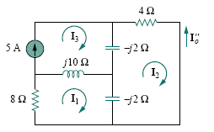
Fig. 4.7.13
For mesh 1
$(8+j8)I_{1}−j{\text{10}}_{3}+j2I_{2}=0$………………….……. (4.7.14)
For mesh 2
$(4−j4)I_{2}+j2I_{1}+j2I_{3}=0$………………………… (4.7.15)
For mesh 3
$I_{3}=5$ ………………………. (4.7.16)
From Eqn. (4.7.15) and (4.7.16),
$(4−j4)I_{2}+j2I_{1}+j\text{10}=0$
Expressing I1 in terms of I2 gives
$I_{1}=(2+j2)I_{2}−5$ ………………………………. (4.7.17)

Substituting Equation (4.7.16) and (4.7.17) into Eq. (4.7.14), we get
$(8+j8)\left[(2+j2)I_{2}−5\right]−j\text{50}+j2I_{2}=0$
Or
$I_{2}=\frac{\text{90}−j\text{40}}{\text{34}}=2\text{.}\text{647}−j1\text{.}\text{176}$
Current $I_{o}^{\text{''}}$ is obtained as
$I_{o}^{\text{''}}=−I_{2}=−2\text{.}\text{647}+j1\text{.}\text{176}$…………………..……… (4.7.18)
From Equation (4.7.13) and (4.7.18), we write
$I_{o}=I_{o}^{'}+I_{o}^{\text{''}}=−5+j3\text{.}\text{529}=6\text{.}\text{12}∠\text{144}\text{.}{\text{78}}^{o}A$

Exercise:
Find $V_{o}$ in the circuit given below using the superposition theorem.
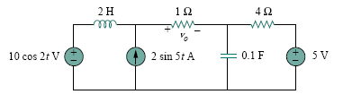
Fig. 4.7.14
Answer:

Source transformation
As shown in the Fig. below, source transformation in the frequency domain involves transforming a voltage source in series with impedance to a current source in parallel with impedance, or vice versa. As we go from one source type to another, we must keep the following relationship in mind:

$V_{S}=Z_{S}I_{S}$ $I_{S}=\frac{V_{S}}{Z_{S}}$
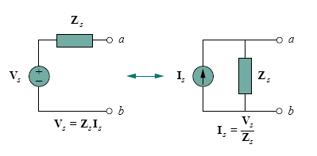
Fig. 4.7.15 Source Transformation
Example:
Calculate VX in the circuit using the method of source transformation.
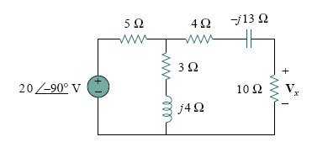
Fig. 4.7.16

Solution:
We transform the voltage source to a current source and obtain the circuit in Fig. 4.7.17(a), where
Is = $\frac{\text{20}∠−{\text{90}}^{o}}{5}=4∠−{\text{90}}^{o}=−j4A$
The parallel combination of 5-Ω resistance and (3+j4) impedance gives
$Z_{1}$ = $\frac{5(3+j4)}{8+j4}=2\text{.}5+j1\text{.}\text{25}Ω$
Converting the current source to a voltage source yields the circuit in Fig. 4.7.17(b), where
$V_{S}=I_{S}Z_{1}=−j4(2\text{.}5+j1\text{.}\text{25})=5−j\text{10}V$
By voltage division,
$V_{X}=\frac{\text{10}}{\text{10}+2\text{.}5+j1\text{.}\text{25}+4−j\text{13}}(5−j\text{10})=5\text{.}\text{519}∠−{\text{28}}^{o}V$

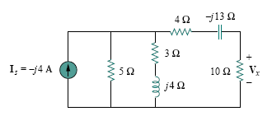
Fig. 4.7.17(a)
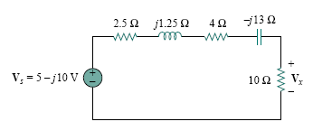
Fig. 4.7.17(b)

Thevenin and Norton equivalent circuit
Thevenin’s and Norton’s theorems are applied to ac circuits in the same way as they are to dc circuits. The only additional effort arises from the need to manipulate complex numbers. The frequency-domain version of a Thevenin equivalent circuit is depicted in Fig. 4.7.18(a), where a linear circuit is replaced by a voltage source in series with impedance. The Norton equivalent circuit is illustrated in Fig. 4.7.18(b), where a linear circuit is replaced by a current source in parallel with impedance. Keep in mind that the two equivalent circuits are related as
$V_{\text{Th}}=Z_{N}I_{N}$, $Z_{\text{Th}}=Z_{N}$
Just as in source transformation. VTh is the open-circuit voltage while IN is the short-circuit current.
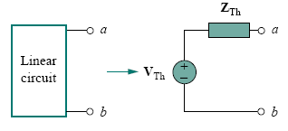
Fig. 4.7.18(a) Thevenin equivalent
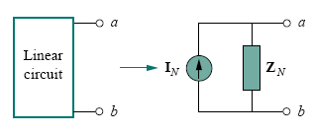
Fig. 4.7.18(b) Norton equivalent

Example:
Obtain the Thevenin equivalent at terminals a-b of the circuit shown below.
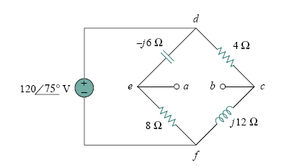
Fig 4.7.19
Solution:
We find ZTh by setting the voltage source to zero. As shown in Fig. (4.7.20), the 8Ω resistance is now in parallel with the $−j$6 reactance, so that their combination gives
$Z_{1}=−j6\text{//}8=\frac{−j6×8}{8−j6}=2\text{.}\text{88}−j3\text{.}\text{84}Ω$
Similarly, the 4Ω resistance is in parallel with the $j$12 reactance, and their combination gives
$Z_{2}=4\text{//}j\text{12}=\frac{j\text{12}×4}{4+j\text{12}}=3\text{.}6+j1\text{.}2Ω$
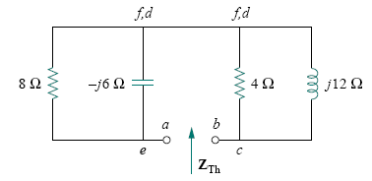
Fig. 4.7.20
The Thevenin impedance is the series combination of Z1 and Z2; that is,
ZTh = Z1 + Z2 = 6.48 − $j$2.64Ω
To find VTh, consider the circuit in Fig. 4.7.21. Currents I1 and I2 are obtained as
$I_{1}=\frac{\text{120}∠{\text{75}}^{o}}{8−j6}A,$ $I_{2}=\frac{\text{120}∠{\text{75}}^{o}}{4+j\text{12}}A$

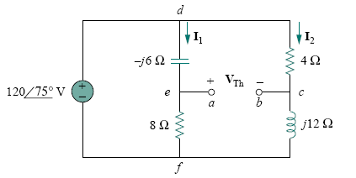
Fig. 4.7.21
Applying KVL around loop bcdeab in Fig. 4.7.21 gives
VTh − 4I2 + $(−j6)$I1 = 0
Or
$V_{\text{Th}}=4I_{2}+j6I_{1}=\frac{\text{480}∠{\text{75}}^{o}}{4+j\text{12}}+\frac{\text{720}∠({\text{75}}^{o}+{\text{90}}^{o})}{8−j6}$
$=\text{37}\text{.}\text{95}∠3\text{.}{\text{43}}^{o}+\text{72}∠\text{201}\text{.}\text{87}$
$=−\text{28}\text{.}\text{936}−j\text{24}\text{.}\text{55}=\text{37}\text{.}\text{95}∠\text{220}\text{.}{\text{31}}^{o}V$
Example:
Obtain current Io in Figure below using Norton’s theorem.
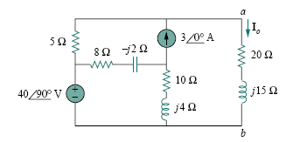
Fig. 4.7.22

Solution:
Our first objective is to find the Norton equivalent at terminals a-b. ZN is found in the same way as ZTh. We set the sources to zero as shown in Fig. 4.7.23. As evident from the figure, the $(8−j2)$ and $(\text{10}+j4)$impedances are short-circuited, so that ZN = 5Ω. To get IN, we short-circuit terminals a-b as in Fig. 4.7.24 and apply mesh analysis. Notice that meshes 2 and 3 form a supermesh because of the current source linking them.
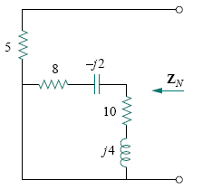
Fig. 4.7.23

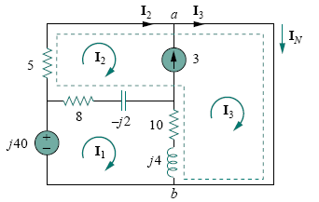
Fig. 4.7.24
For mesh 1 from Fig. 4.7.24
$−j\text{40}+(\text{18}+j2)$I1 − $(8−j2)$I2 − $(\text{10}+j4)$I3 = 0 ………………….… (4.7.19)
For the supermesh,
$(\text{13}−j2)$I2 + $(\text{10}+j4)$I3 − $(\text{18}+j2)$I1 = 0..………………….….. (4.7.20)
At node a, due to the current source between meshes 2 and 3,
I3 = I2 + 3 ……………….. (4.7.21)
Adding Equations (4.7.19) and (4.7.20) gives
$−j\text{40}+5$I2 = 0 $⇒$ I2 = $j8$
From Eq. (4.7.21),
I3 = I2 + 3 = $3+j8$
The Norton current is
IN = I3 = $(3+j8)$A
Figure 4.7.25 shows the Norton equivalent circuit along with the impedance at terminals a-b. By current division,
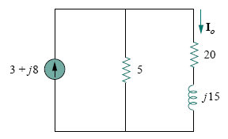
Fig. 4.7.25

$I_{o}=\frac{5}{5+\text{20}+j\text{15}}I_{N}=\frac{3+j8}{5+j3}=1\text{.}\text{465}∠\text{38}\text{.}{\text{48}}^{o}A$

Maximum power transfer in AC circuits
In the previous chapter we solved the problem of maximizing the power delivered by a power-supplying resistive network to a load RL. Representing the circuit by its Thevenin equivalent, we proved that the maximum power would be delivered to the load if the load resistance is equal to the Thevenin resistance RL = RTh. We now extend that result to ac circuits.
Consider the circuit in Fig. 4.7.26, where an ac circuit is connected to a load ZL and is represented by its Thevenin equivalent. The load is usually represented by impedance, which may model an electric motor, an antenna, a TV, and so forth. In rectangular form, the Thevenin impedance ZTh and the load impedance ZL are
$Z_{\text{Th}}=R_{\text{Th}}+{\text{jX}}_{\text{Th}}$……………………….…… (4.7.22)
$Z_{L}=R_{L}+{\text{jX}}_{L}$ ………………………….… (4.7.23)

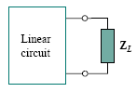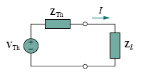
- (b)
Fig. 4.7.26 finding the maximum average power transfer:
- Circuit with a load, (b) the Thevenin equivalent.

The current through the load is
$I=\frac{V_{\text{Th}}}{Z_{\text{Th}}+Z_{L}}=\frac{V_{\text{Th}}}{(R_{\text{Th}}+{\text{jX}}_{\text{Th}})+(R_{L}+{\text{jX}}_{L})}$………………… (4.7.24)
The average power delivered to the load is given by:
$P=\frac{1}{2}{\left|I\right|}^{2}R_{L}=\frac{V_{\text{Th}}^{2}R_{L}/2}{(R_{\text{Th}}+R_{L})^{2}+(X_{\text{Th}}+X_{L})^{2}}$ ……………….…. (4.7.25)
Our objective is to adjust the load parameters $R_{L}$and $X_{L}$so that P is maximum. To do this we set $∂P/∂R_{L}$and $∂P/∂X_{L}$equal to zero. From Eq. (4.7.25), we obtain
$\frac{∂P}{∂X_{L}}=−\frac{{\left|V_{\text{Th}}\right|}^{2}R_{L}(X_{\text{Th}}+X_{L})}{{\left[(R_{\text{Th}}+R_{L})^{2}+(X_{\text{Th}}+X_{L})^{2}\right]}^{2}}$……………………………… . (4.7.26a)
$\frac{∂P}{∂R_{L}}=\frac{{\left|V_{\text{Th}}\right|}^{2}\left[(R_{\text{Th}}+R_{L})^{2}+(X_{\text{Th}}+X_{L})^{2}−2R_{L}(R_{\text{Th}}+R_{L})\right]}{2{\left[(R_{\text{Th}}+R_{L})^{2}+(X_{\text{Th}}+X_{L})^{2}\right]}^{2}}$…………..… (4.7.26b)
Setting $∂P/∂X_{L}$ to zero gives
$X_{L}=−X_{\text{Th}}$……………………….…….….. (4.7.27)
And setting $∂P/∂R_{L}$to zero gives

$R_{L}=\sqrt{R_{\text{Th}}^{2}+(X_{\text{Th}}+X_{L})^{2}}$……………..……. (4.7.28)
Combining Equations (4.7.27) and (4.7.28) leads to the conclusion that for maximum average power transfer, ZL must be selected so that$X_{L}=−X_{\text{Th}}$, and $R_{L}=R_{\text{Th}}$ i.e.
ZL =$R_{L}+{\text{jX}}_{L}=R_{\text{Th}}−{\text{jX}}_{\text{Th}}=Z_{\text{Th}}^{}$…………………. (4.7.29)
For maximum average power transfer, the load impedance ZL must be equal to the
complex conjugate of the Thevenin impedance ZTh.
This result is known as the maximum average power transfer theorem for the sinusoidal steady state. Setting $R_{L}=R_{\text{Th}}$ and $X_{L}=−X_{\text{Th}}$ in Eq. (4.7.25) gives us the maximum average power as
$P_{\text{max}}=\frac{{\left|V_{\text{Th}}\right|}^{2}}{8R_{\text{Th}}}$………………………………………. (4.7.30)
In a situation in which the load is purely real, the condition for maximum power transfer is obtained from Eq. (4.7.28) by setting $X_{L}=0$ that is,
$R_{L}=\sqrt{R_{\text{Th}}^{2}+X_{\text{Th}}^{2}}=\left|Z_{\text{Th}}\right|$……………………………. (4.7.31)
This means that for maximum average power transfer to a purely resistive load, the load impedance (or resistance) is equal to the magnitude of the Thevenin impedance.

Example:
Determine the load impedance ZL that maximizes the average power drawn from the circuit of Fig. 4.7.27. What is the maximum average power?
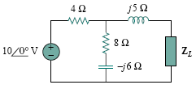
Fig.4.7.27
Solution:
First we obtain the Thevenin equivalent at the load terminals. To get ZTh, consider the circuit shown below. We find
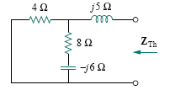
ZTh = $j5+4\text{//}(8−j6)=j5+\frac{4(8−j6)}{4+8−j6}=2\text{.}\text{933}+j4\text{.}\text{467}Ω$
To find VTh, consider the circuit given below. By voltage division,
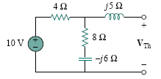
VTh = $\frac{8−j6}{4+8−j6}×\text{10}=7\text{.}\text{454}∠−\text{10}\text{.}3°$V
The load impedance draws the maximum power from the circuit when
ZL = $Z_{\text{Th}}^{}$ = 2.933− j4.467 Ω
The maximum average power is
$P_{\text{max}}=\frac{{\left|V_{\text{TH}}\right|}^{2}}{8R_{\text{Th}}}=\frac{(7\text{.}\text{454})^{2}}{8(2\text{.}\text{933})}=2\text{.}\text{368}$W

- Page 43 angle is mentioned as -90 while solving th eproblem, but it is zero degree.

